**Screenshot of a database diagram.**

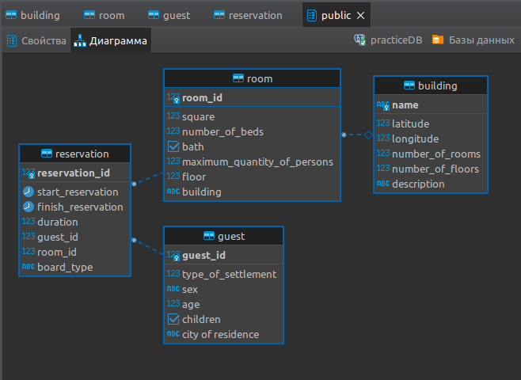

**Screenshot of 3 check constraints.**

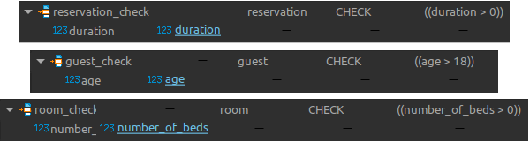

**Screenshot of data from the “Reservations” table.**

